
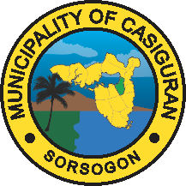
Republic of the Philippines
Province of Sorsogon
MUNICIPALITY OF CASIGURAN

NOTICE OF POST-QUALIFICATION RESULT

_____________

{{title_upper}}. {{proprietor_upper}}
Proprietor //Owner
{{company_name_upper}}
City Employees Village, Cabid-An, Sorsogon

Dear Ma’am /Sir,
After determining your bid as the Lowest Calculated Bid for the {{project_title_upper}}, upon post-qualification involving the careful examination, validation and verification of the eligibility, technical and financial requirements that you have submitted for the bidding, we are happy to inform you that you have successfully passed post qualification and, therefore, now consider your bid as the Lowest Calculated Responsive Bid for the said contract.
Upon the approval of this finding by the Head of the Procuring Entity, we will recommend you for Award of Contract.

Very truly yours,

ARLIE H. CORAÑES
BAC Chairman

Received by the Bidder:

{{proprietor_upper}}
{{company_name_upper}}

Date: {{date}}

